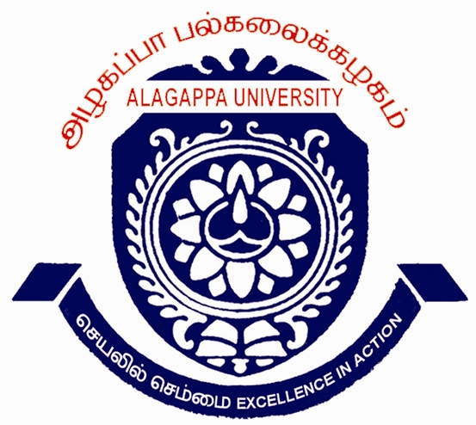

ALAGAPPA UNIVERSITY
(A State University Re-Accredited with ‘’A’’ Grade by NAAC)
KARAIKUDI – 630 003
ADMISSION NOTIFICATION 2012-13

Applications are invited for admissions to the following Post Graduate / Graduate
programmes offered in the University Departments and Constituent Colleges for
the academic year 2012-13
01.MBA  02.MBA (Banking & Insurance)  03.MBA (Corporate Secretaryship)  04.MBA (International Business & E-Commerce)  05.MCA  06.M.Sc.Biotechnology | 07.Post M.Sc. Advanced Diploma in Molecular Diagnostics  (ADMD)(DBT – GoI Funded)  (One Year – studentship Rs.5000/- p.m) 08.M.Ed.  09.B.Ed.  10.M.P.Ed.
Sl.No.1 to 6 – Admission based on Entrance Test and Group Discussion/Interview marks.
Sl.No.7,8,9 – Admission based on Entrance Test marks only.
Sl.No.10 – Admission based on Entrance Test, Medical Test, Physical Efficiency Test ,
Games Test & Interview.

Entrance Test Dates & Centres
 | Programmes | Date | Time | Centre
1  2  3  4  5 | MBA (all programmes)  M.Sc., Biotech / Post M.Sc. ADMD  MCA  B.Ed.  M.Ed. / M.P.Ed. | 11.03.12  11.03.12  11.03.12  18.03.12  18.03.12 | 10 to 12 noon  10 to 12 noon  2 to 4 pm  10 to 12 noon  2 to 4 pm | Karaikudi & Chennai  Karaikudi & Chennai  Karaikudi & Chennai  Karaikudi only  Karaikudi only
The venue of Entrance Test will be indicated in the Applicant’s Hall Ticket.
Date of Interview / Group Discussion / Medical Test etc., if applicable will be intimated later.

Candidates applying for more than one programme will have to use separate application forms. Application and prospectus can be obtained from the Registrar, Alagappa University, Karaikudi – 630 003 on requisition along with a crossed Demand Draft for Rs.500/- (Rs.250/- for SC/ST applicants on submission of a copy of Community Certificate) drawn in favour of “The Registrar, Alagappa University” payable at Karaikudi by post or in person. Applications can also be downloaded from the website www.alagappauniversity.ac.in . Downloaded filled in application should be accompanied by a DD for the specified amount of application cost as mentioned above. Candidates appearing for the final year/semester examination can also apply.

Contact Phone Numbers: 04565-228112,228113

Last date for the issue and receipt of filled-in applications: 01.03.2012

Karaikudi Dr.K.Manimekalai
01.02.2012 Registrar i/c

